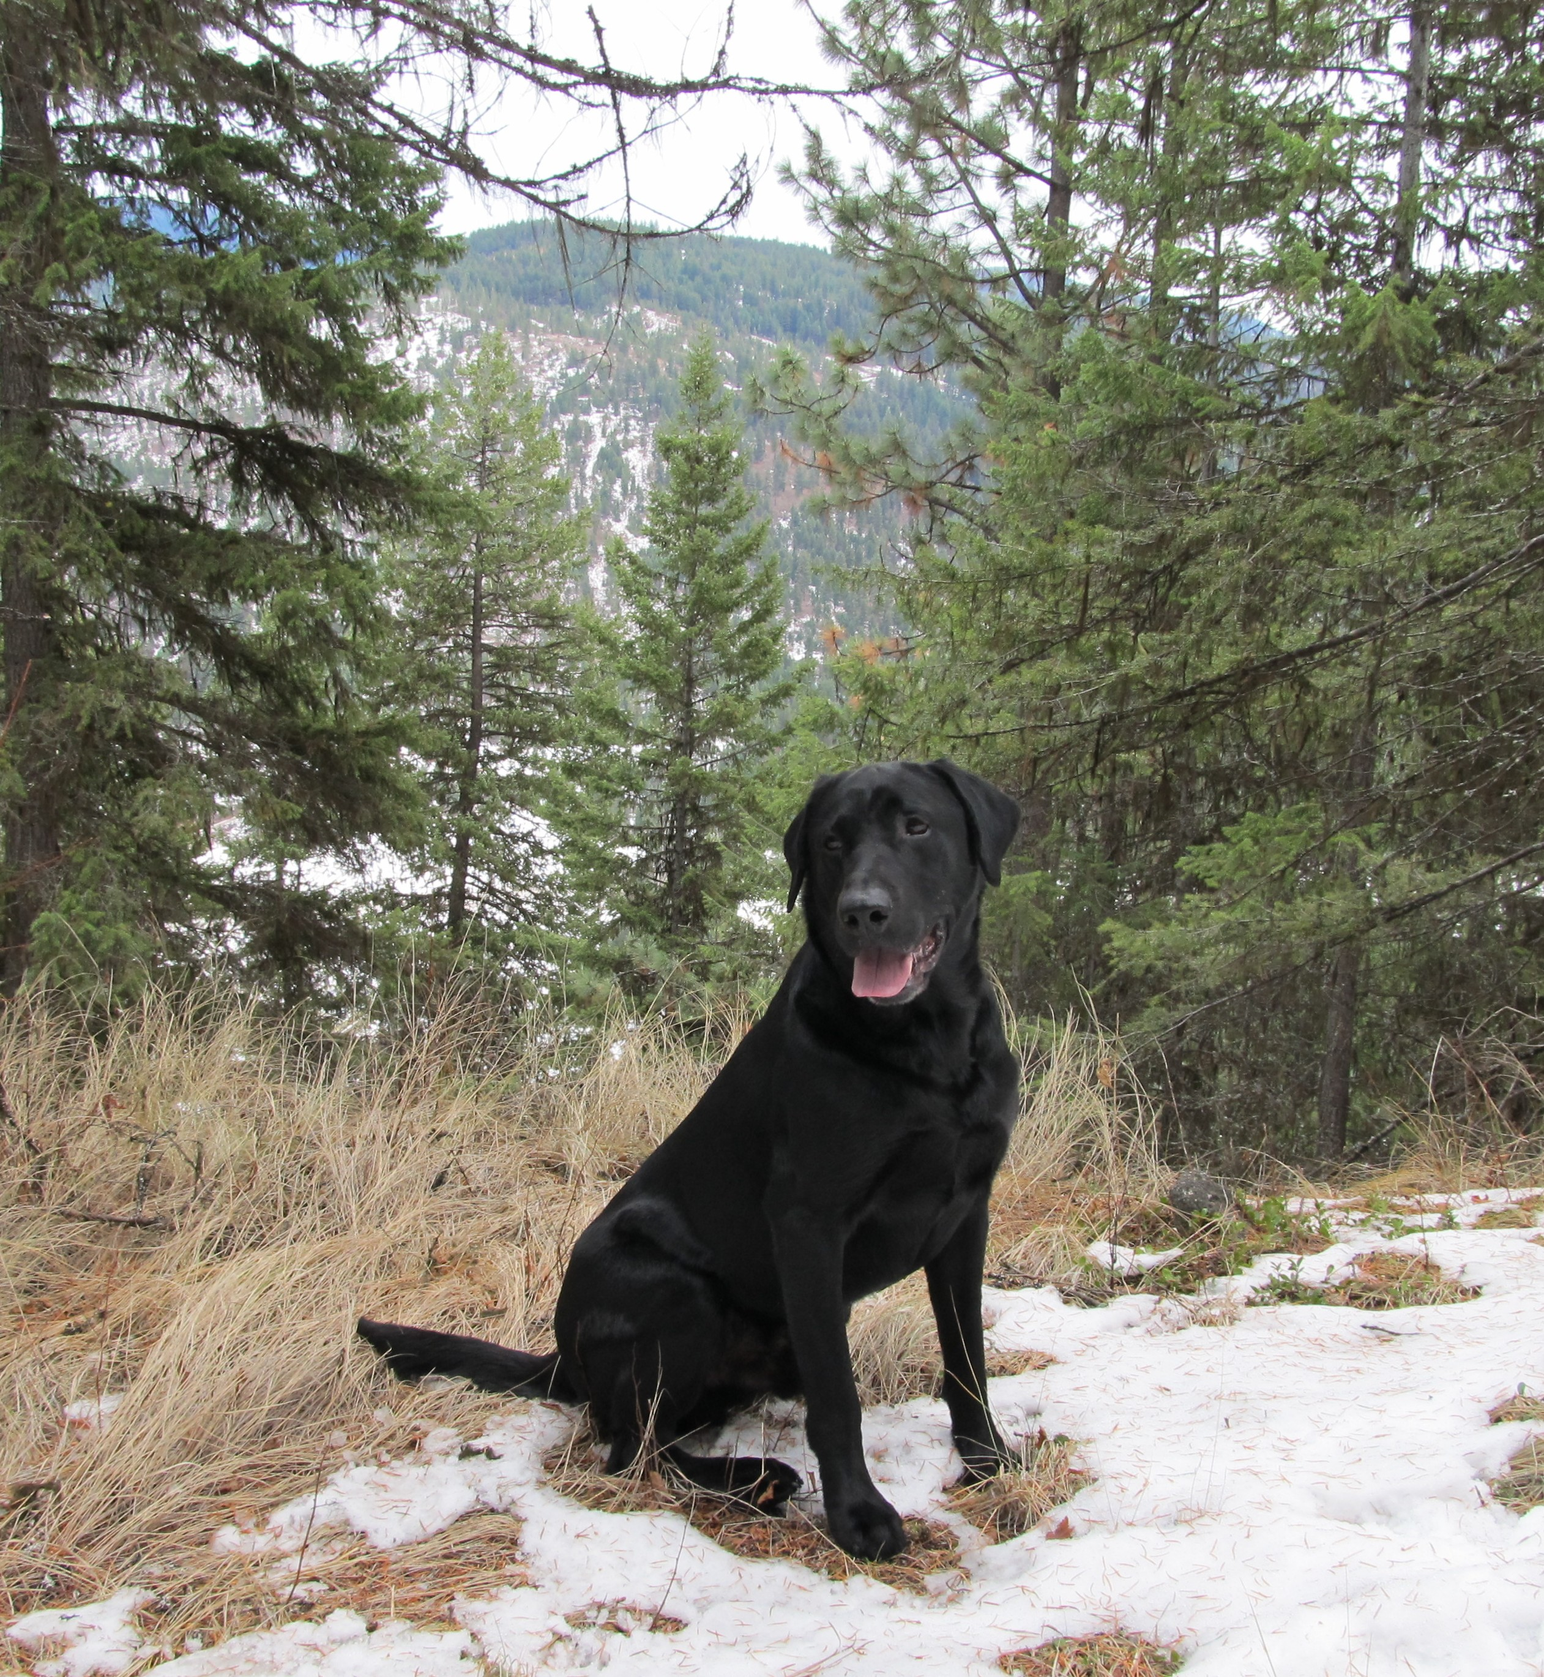
FC AFC Riverrun’s True North
Pete

Pete’s Achievements: Health Certificates:

- 34 derby Points, #8 on 2007 derby list
- Currently has 105 ½ all age points
- Double Header Winner, 2012 ORTC
- Qualified for 6 Nationals
- Top ten open point earner 2009/2011
- #3 all age earner in 2011
- #5 Amateur point earner 2011

- Hips Excellent LR-163607E24M-PI
- Normal Elbow LR-EL32858M24-PI
- EIC Carrier, CNM Clear
- CERF LR-47338 (06)
- CHIC #37248
- Yellow factored
- Frozen, Natural or Side/Side AI

Characteristics:

- Excellent training attitude
- Handles pressure, comes back eager to try again
- Runs blinds as hard as marks
- Athletic, stylish, quiet, not a barker
- Pete hunts ducks, pheasants, and blue grouse every fall
- Patient in the duck blind
- Excellent with kids, great companion

